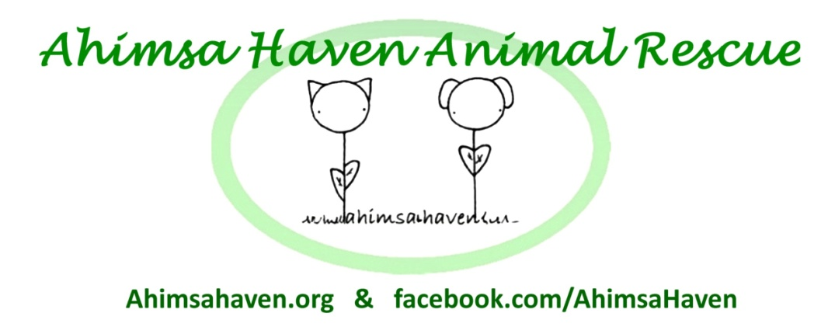
381R Baldwinville Rd.
Templeton MA 01468
Phone: 978-939-8464
Email: info@ahimsahaven.org
Web: ahimsahaven.org

Adoption Agreement
Terms of Adoption:
My signature below indicates that I am at least 21 years of age and intend to be the legal owner and the person responsible for the care and well being of any pet I adopt from Ahimsa Haven, Inc. By signing this application, I give representatives of Ahimsa Haven Animal Rescue, Inc. permission to contact my veterinarian, landlord, personal references, or other rescue groups/humane societies for information to aid in the evaluation of whether this pet is appropriate for me. I also give them permission to visit my home either before or after the adoption (or both) unannounced for purposes of checking to see if this pet is being treated according to this adoption agreement and in a humane manner. I understand that any misrepresentation of the true facts in this application will invalidate the adoption agreement and give Ahimsa Haven Animal Rescue, Inc. the right to reclaim the pet without refund of the adoption fee.
Cost:
Adoption fees cover our cost of spaying/neutering, vaccinations, worming, and the care and feeding of animals in our care. If you feel that the animal you are adopting might be considered a special circumstances dog needing extra care, please don't hesitate to discuss the fee with us. Our goal is to find all dogs a loving forever home. Adoption fees must be paid in full at the time of adoption. NO EXCEPTIONS. We accept cash, money order, or check.
Temperament:
I understand that this pet may not have been temperament tested and/or evaluated professionally, and that Ahimsa Haven Animal Rescue, Inc. makes no representations or warranties regarding the pets behavior with adults, children, or other animals, or provide other guarantees as to the pets characteristics, personality, or training. I understand and agree that Ahimsa Haven Animal Rescue, Inc. and/or any of its representatives are not responsible for any injuries or property damage resulting from the possession or ownership of this pet.
Medical:
I understand that this animal has been given certain basic inoculations and other medical treatment for problems that Ahimsa Haven Animal Rescue, Inc. is aware of and can treat before adoption. The pet I am adopting is accepted by me "as is." I agree to provide yearly checkups, vaccines, and heartworm prevention as well as treatment for emergencies. I understand that Ahimsa Haven, Inc. makes no representations or warranties regarding the current or future medical condition of the pet and is not responsible for additional medical care for the pet.

DOGS: While most dogs are provided neutered, state law requires that intact adopted dogs have a $30 neuter
deposit which will be returned to me when I neuter this dog within 60 days.

CATS: If the cat is not already fixed because it does not meet weight requirements, I agree to get the cat to its
spay/neuter appointment before six months of age.

I understand that if I do not spay or neuter this pet, that Ahimsa Haven Animal Rescue, Inc. has the right to take this pet from me and this application and/or adoption agreement is rendered invalid.

Care:
As this pet's new owner, I agree to provide the training required to ensure a secure and respectful pet/owner relationship. I will see that this pet has the physical exercise and the mental stimulation it needs to ensure a physically and mentally healthy animal. I will provide fresh water at all times.

DOGS: I will feed the dog a minimum of twice daily the appropriate fresh and healthy food. I will license the dog in
the town I live in and tag the pet for identification purposes. I will not let the dog run free without supervision, be
chained out all day or all night, be around children under 14 years of age without adult supervision, ride loose in the
back of an open truck, or remain unattended in any vehicle when the temperature in the vehicle is over 70⁰ F.

CATS: I will feed the cat a high quality diet in an appropriate amount for the cat's size. I will not let this cat outside. I
will not declaw this cat. I will make sure this cat wears identification on a safety collar. I will not let the cat remain
unattended in any vehicle when the temperature in the vehicle is over 70⁰ F.

Adoption Termination:
I understand that, if for any reason, the adoption is not satisfactory for the pet or adoptive owner that Ahimsa Haven Animal Rescue, Inc. requires the pet be returned to Ahimsa Haven Animal Rescue, Inc. even if that date is many years in the future. Should Ahimsa Haven Animal Rescue, Inc. no longer exist as an entity, the owner will place the animal with another no-kill shelter. If the pet is returned within one month by the adoptive owner the adoption fee will be refunded in full. Ahimsa Haven Animal Rescue, Inc. asks that pets be kept a minimum of 48 hours if possible to allow both pet and owner the time necessary to adjust to their new living situation.

The pet may not be sold or given to a new owner without Ahimsa Haven Animal Rescue, Inc.'s prior written approval. If the pet is given/sold to other person(s), I will pay a fine of not less than $500 to Ahimsa Haven on written request. Ahimsa Haven Animal Rescue, Inc. reserves the right to take back this pet if it is ever neglected, abused, or improperly cared for including lack of veterinary care, and I agree to relinquish custody immediately upon request without the need for further legal writ or court order. I agree to promptly contact Ahimsa Haven Animal Rescue, Inc. if the pet is lost for more than 24 hours.
I, on behalf of myself and all persons resident in the household where _____________ [pet's name] will reside, hereby accept possession of title to _____________ [pet's name] and responsibility for the animal identified above and hereby release, indemnify and discharge Ahimsa Haven Animal Rescue, Inc., and its officers, employees and agents, forever from and against any liability for any injury or damage to any person or property caused in the future by this adoption, or by said pet, and from and against any causes of actions, suits or demands whatsoever that may arise as a result of such injury or damage.
Name (Printed): _______________________________________________ Email: _______________________________

Address: _____________________________________________________ Phone: ______________________________

____________________________________________________________ Amount Received _______________
Signature of Adoptive Owner Date
⃝ Cash
_____________________________________________________________ ⃝ Check # _________
Signature of Ahimsa Haven Representative Date ⃝ Money Order # _________

Photo Release Form

I grant Ahimsa Haven Animal Rescue, Inc., its representatives and employees the right to take photographs of me and the newly adopted animal on the day of adoption. I authorize the use of such photographs for lawful purposes, including but not limited to publishing on Facebook, the Ahimsa Haven website, at Ahimsa Haven sanctioned events, and local Newspapers, with or without the use of my name.

_____________________________________________________________
Signature of Adoptive Owner Date Doc. Rev 1-14-2017

