**Mission**  
To rescue, rehabilitate, and rehome companion animals.

**Motto**  
To do no harm, in thought or deed, to any living creature.

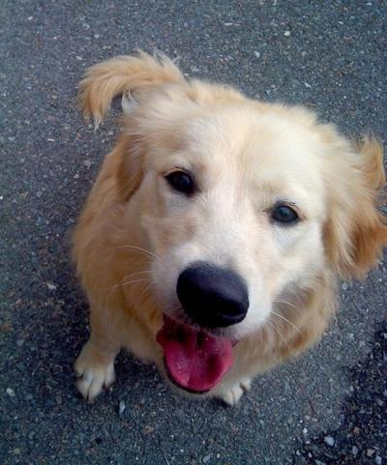

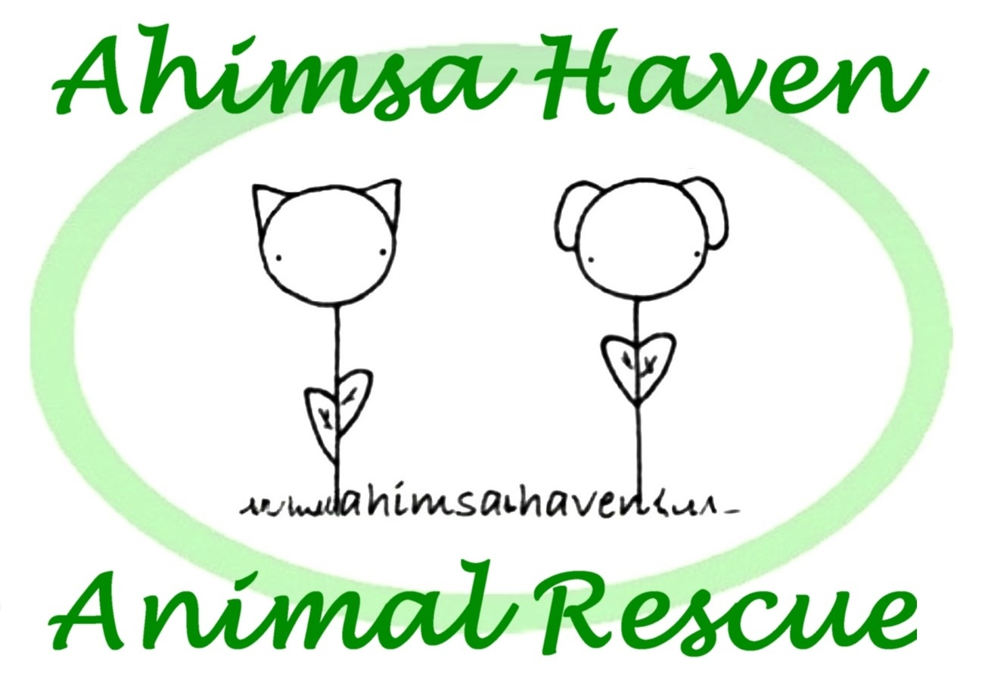

# Who We Are

## **About Us**

Ahimsa Haven was incorporated in 1999 as a nonprofit animal rescue group. Our mission is to find good homes for abused, abandoned, homeless and unwanted domestic animals. We are raising money to build a shelter in North Central Massachusetts and to provide emergency medical care for animals in need, along with routine medical care for animals in our foster care program. Every penny we raise goes to the animals - no one gets a salary!



## **Contact Us**

**Phone:** 978-297-2673  
**Email:** [info@ahimsahaven.org](mailto:info@ahimsahaven.org)  
**Web:** ahimsahaven.org/

Ahimsa Haven Animal Rescue

381R Baldwinville Rd.

Templeton MA 01468



www.facebook.com/AhimsaHaven

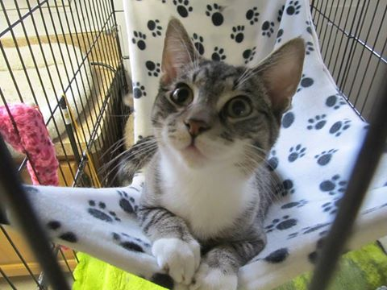

We are proud to be a no kill animal rescue. Because we have a limited intake policy (taking only animals we can humanely accommodate), we are not forced to euthanize due to lack of space.

Our policy states that only when an animal is suffering, and has been given a poor prognosis by a veterinarian, or is a danger to our volunteers, the public, or other animals, may we choose to humanely euthanize.

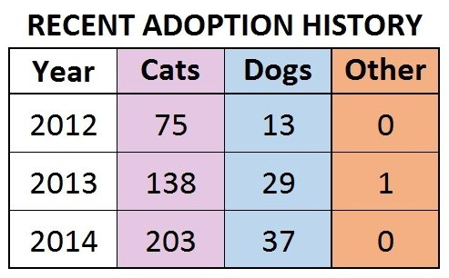

Ahimsa Brochure 2015-revF.docx

In 2013 Ahimsa Haven transitioned from being a foster-based rescue to having a shelter in Templeton, Massachusetts. The shelter has space for up to 5 dogs and 15 cats. We worked with the Massachusetts Department of Agricultural Resources to get the building up to par.

We are excited to be able to use the building in the spirit the volunteers who worked so hard to build it in 2006 intended. The facility enables us to have a stronger impact on local animals who find themselves in need. Treating each with kindness, in a humane environment with lots of enrichment, interaction, and love remains core to our values.

Along with an increase of the number of animals we can help, our impact on the human community has also grown. The number of volunteer opportunities for residents of our community has tripled.

Bringing adopters and homeless animals together, finding out what makes each one tick, and, through a thoughtful process, making a match that will last a lifetime will remain our core activity, regardless of size or location.

We look forward to continuing our expansion trend. Building our own, larger facility remains our goal - a larger facility will provide a powerful addition to our ability to care for animals.

“I just wanted to say thank you for all you do. What you give all the animals in your care is amazing. You are all incredibly wonderful people and the animals are so lucky to have you. I adopted Birdie and Cookie … They are both doing great! They make us laugh every single day and we love them so much.”(The Stevens Family)



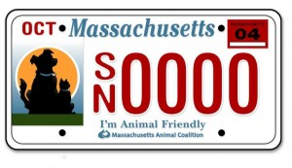

**www.massanimalcoalition.org**

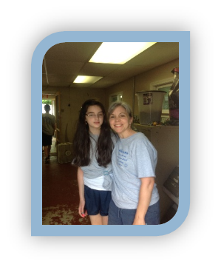

**Volunteering in the Templeton Shelter**

## **Values**

* We believe that companion animals are a part of their human family.
* We believe in finding the best match between the animals in our care and adoptive families.
* We believe that all pets should be spayed or neutered.
* We believe in working with local animal control agencies and rescue groups to help place animals.
* We believe in using positive training methods.
* We believe exercise and leadership are key to a successful human and animal relationship.