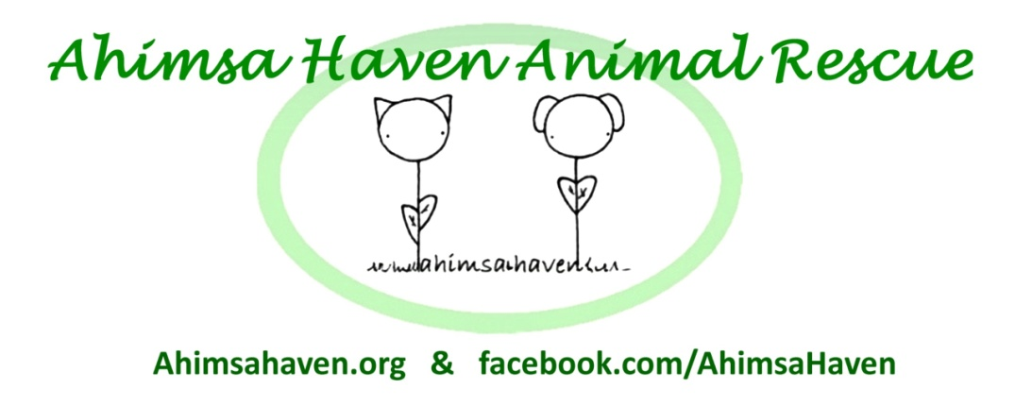
381R Baldwinville Rd.
Templeton MA 01468
Phone: 978-297-2673
Email: info@ahimsahaven.org
Web: ahimsahaven.org

Foster Agreement for ____________

Name of Foster Parent (Printed): _________________________________ Email: _______________________________

Address: _____________________________________________________ Phone: ______________________________

As a Foster Parent, I agree to:

- Act as this animal's advocate, and inform an officer of Ahimsa Haven of the need for preventative and emergent medical care.

- Provide transportation to any veterinary or groomer visits (to be paid by Ahimsa Haven).

- Administer any medications or supplements as prescribed by a veterinarian or recommended by an officer of Ahimsa Haven.

- Abide by Ahimsa Haven's adoption policies in the care of this animal including: not kept in basement, not left unattended outside, never allowed loose outside, wearing a collar with rabies and ahimsa Haven tags at all times. Cats are to be kept indoors only.

- Take reasonable precautions to protect my property, pets, and people in my home. Ahimsa Haven is not responsible for damages caused by the animal while in foster care.

- Communicate any behavioral issues including inappropriate bathroom habits to an Ahimsa Haven agent immediately.

Please Turn Over To Complete This Form

As a Foster Parent, I agree to:

- Notify an officer of Ahimsa Haven immediately if I am no longer able to care for the animal.

- Respond to approved applicants within 24 hours to arrange for a meeting.

- Ensure proper documentation is available prior to adoption including proof of - Spay/Neuter (if applicable)
- Rabies
- Distemper (FVCRP for cats/DHPP for dogs)
- Microchipping
- Disease testing (FLV/FeLV for cats/ 4 way "snap"............

- Provide an Ahimsa Haven officer with updated photos and information on the animal's personality and temperament within a reasonable amount of time if asked.

- Inform an officer of Ahimsa haven immediately if I am unable to abide by any part of this agreement.

____________________________________________________________
Signature of Foster Parent Date

____________________________________________________________
Signature of Ahimsa Haven Inc. Representative Date

Doc. Rev 1-10-2016

