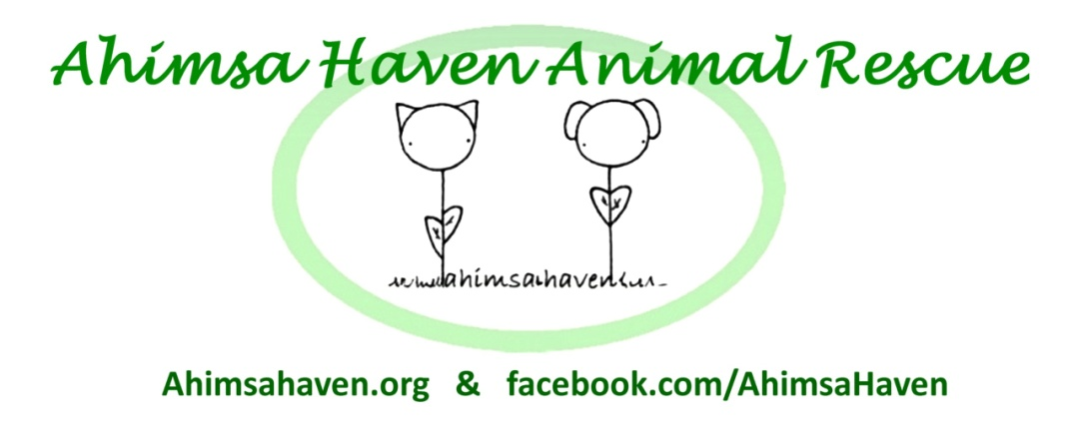
381R Baldwinville Rd.
Templeton MA 01468
Phone: 978-939-8464
Email: info@ahimsahaven.org
Web: ahimsahaven.org

Foster Agreement for ____________

Name of Foster Parent (Printed): _________________________________ Email: _______________________________

Address: _____________________________________________________ Phone: ______________________________

As a Foster Parent, I agree to:

- Act as this animal's advocate, and inform an officer of Ahimsa Haven Animal Rescue, Inc. of the need for preventative and emergent medical care.

- Provide transportation to any veterinary or groomer visits (to be paid by Ahimsa Haven Animal Rescue, Inc.) as authorized by an Ahimsa Haven Animal Rescue officer.

- Administer any medications or supplements as prescribed by a veterinarian or recommended by an officer of Ahimsa Haven Animal Rescue, Inc.

- Abide by Ahimsa Haven Animal Rescue Inc.'s adoption policies in the care of this animal including:

  - Do not keep animal in the basement.
  - Do not leave unattended or tied outside.
  - Never allow loose outside.
  - Dogs must wear a collar with identification tags at all times.
  - Cats are to be kept indoors only.

- Take reasonable precautions to protect my property, pets, and people in my home. Ahimsa Haven Animal Rescue, Inc. is not responsible for damages caused by the animal while in foster care.

Please Turn Over To Complete This Form

As a Foster Parent, I agree to:

- Communicate any behavioral issues including inappropriate bathroom habits to an Ahimsa Haven Animal Rescue, Inc. agent immediately.

- Notify an officer of Ahimsa Haven Animal Rescue, Inc. immediately if I am no longer able to care for the animal.

- Respond to approved applicants within 24 hours to arrange for a meeting.

- Ensure proper documentation is available at all times including proof of:

  - Spay/Neuter (if applicable)
  - Rabies
  - Distemper (FVCRP for cats/DHPP for dogs)
  - Microchipping
  - Disease testing (FIV/FeLV for cats over 6 months old)
  - Disease testing (heartworm/lyme/erlichia/anaplasma for dogs over 6 months old)

- Provide an Ahimsa Haven Animal Rescue, Inc. officer with updated photos and information on the animal's personality and temperament within a reasonable amount of time if asked.

- Inform an officer of Ahimsa Haven Animal Rescue, Inc. immediately if I am unable to abide by any part of this agreement.

- To obtain permission before incurring expenses on Ahimsa Haven Animal Rescue
Inc.'s behalf.

_________________________________________________________________________
Signature of Foster Parent Date

_________________________________________________________________________
Signature of Ahimsa Haven Animal Rescue, Inc. Representative Date

Doc. Rev 1-14-2017

