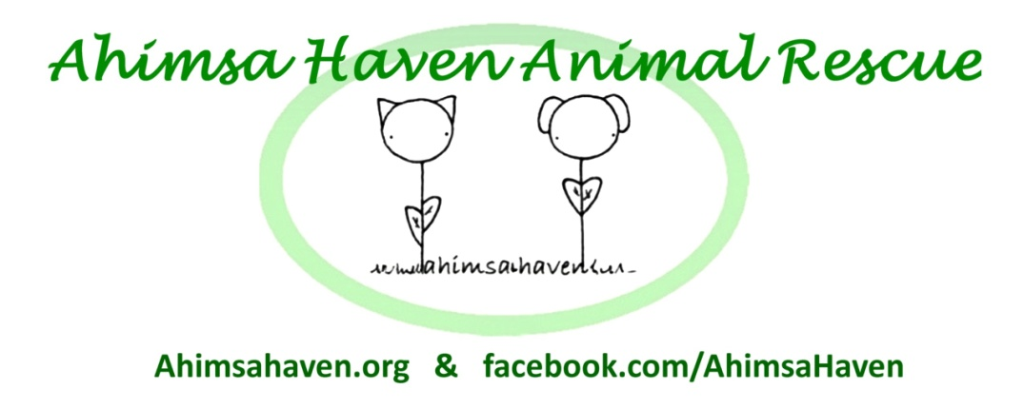
381R Baldwinville Rd.
Templeton MA 01468
Phone: 978-939-8464
Email: info@ahimsahaven.org
Web: ahimsahaven.org

Surrender Form

I, being the owner of ___________________________ [pet's name], a ______________________________ [age sex and breed of animal], herby voluntarily relinquish all claims and ownership of said animal to Ahimsa Haven Animal Rescue, Inc. and members thereof. I certify that I am the rightful owner of this animal and that no other person has ownership interest, and I understand that I cannot reclaim this animal once it is in the possession of Ahimsa Haven Animal Rescue, Inc. By signing this form I give permission for Ahimsa Haven Animal Rescue, Inc. to contact my veterinarian to obtain information or medical records on this animal. I certify that the information on this form is true and correct to the best of my knowledge.

________________________________________________________________ Surrender Fee __________________
Signature of Surrenderer Date
⃝ Cash
________________________________________________________________ ⃝ Check # _________
Signature of Ahimsa Haven Animal Rescue, Inc. Representative Date ⃝ Money Order # _________

Name (Printed): _______________________________________________ Email: _______________________________

Address: _____________________________________________________ Phone: ______________________________

Turn over to complete this form.
Please fill out the following questions to the best of your ability.

Why are you surrendering this animal?

Where did you get the animal from?

How long have you had the animal?

Does this animal have any medical conditions?

Is this animal on any medication?

Is this animal up to date on vaccines?

Please list any vets that have treated this animal:

If this animal has ever bitten a person or another animal, please give details:

Please describe this animal's personality. Is it good with children, other animals, etc.? Does it have any behavioral issues?

Doc. Rev 1-4-2017

