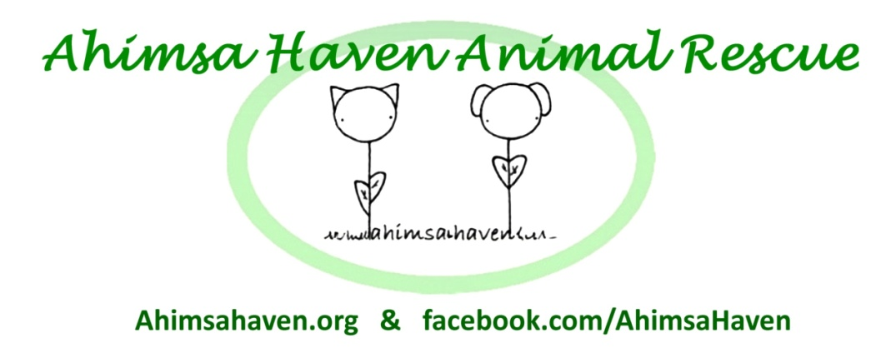
381R Baldwinville Rd.
Templeton MA 01468
Phone: 978-939-8464
Email: info@ahimsahaven.org
Web: ahimsahaven.org

Ahimsa Haven is a 501(c)3 non-profit, no-kill, all volunteer run animal rescue.

Volunteer Form
I would like info on volunteering with Ahimsa Haven Animal Rescue
(must be 18 or older to volunteer)

Name: _________________________________ ____ Email: _____________________________________
Phone: _____________________________________

Please check off any volunteer opportunities you might be interested in:

Volunteer opportunities at PetSmart include:

    - Providing care for the cats (feeding, cleaning litterboxes, etc.)
    - Socializing with the cats (petting, brushing)
    - Working at "Adoption & Info” events at PetSmart (Typically Sat. & Sun. 12-4)

Other volunteer opportunities (outside of PetSmart) include:

- Foster cats, kittens, or dogs in my home
- Provide transportation for animals to vet appointments
- Work at fundraising events
- Cat/Dog care at our shelter in Templeton

A volunteer coordinator will call you shortly. Thanks!
Like us on Facebook for all of the latest Ahimsa Haven news!
Doc. Rev 1-14-2017

