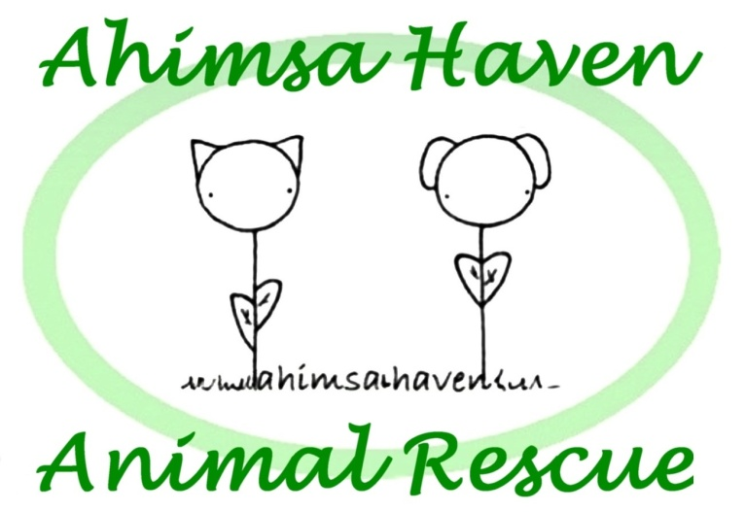

Ahimsa Haven Animal Rescue
Volunteer Handbook
(revised 09/2017)

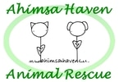
Welcome

Welcome!
Thank you for choosing Ahimsa Haven! We rely solely on volunteers, and your contribution has a direct impact on our ability to rescue abandoned and unwanted animals. There are many volunteer opportunities available, including assisting with fundraising, providing transportation and actually caring for the animals.

Ahimsa (pronounced Ah-HIM-sa) is a concept popular in eastern religions, and means to do no harm, in thought or deed, to any living creature. Ahimsa Haven was incorporated in 1999 and is licensed by the Department of Agriculture as an animal rescue. We also have our 501(c)3 non-profit status from the Department of Revenue.

Founded as a foster-based rescue that financially supported Winchendon Animal Control, Ahimsa Haven opened its first shelter in 2013. In addition to the facility in Templeton, we also use foster homes to shelter animals while they await forever homes.

We believe in finding the best match between families and the animals in our care. This means a more stringent application policy than some other shelters and rescues. All potential adoptive parents must show a consistent history of vaccination for prior pets (including heartworm preventative), and a stable residence of more than 1 year. Our organization does not condone the breeding of companion animals under any circumstances.

If you know of someone looking to adopt a pet, remember that we require a completed adoption application (available on our website). In the case that an adoption doesn’t work out, we require that the animal come back to us, regardless of how long ago the animal was adopted.

You’ll find more information about our organization on our website, www.ahimsahaven.org, including animals available for adoption (updated daily) upcoming events and tons of other information.

We look forward to working with you. Thank you for helping us save lives!

Nicole Roberts, President

For Your Records

Care and Caution Agreement

Interacting with shelter animals exposes you to injury and illness.

It is expected that volunteers conduct their duties with care and caution, to reduce the risk of illness and injury to themselves, to the animals they care for, and to the public. This includes (but is not limited to): keeping animals under safe control at all times; practicing good sanitation habits and disease control preventatives; watching each individual animal for signs it gives you and handling appropriately; and making use of the information provided on each animal's cage card and by electronic or verbal communication when making choices on how to handle (or not handle) the animal.

Volunteers who do not conduct their duties with care and caution will be subject to disciplinary action up to and including immediate dismissal.

______________________________________________________________________
Volunteer Signature Print Date

______________________________________________________________________Ahimsa Haven Animal Rescue, Inc. Rep. Print Date

For Your Records

Volunteer Release

1. I understand that I will be handling animals while providing my volunteer services for Ahimsa Haven Inc. and their participating rescue partners and therefore there exists a risk for personal injury. On behalf of myself, my heirs, personal representatives, and executor, I release, discharge, indemnify and hold harmless Ahimsa Haven Inc., its agents, servants and employees from any and all claims, causes of action or demands of any nature or cause connected with my volunteer contract. This could include any costs, attorney’s fees and court costs incurred by Ahimsa Haven Inc. in connection with my volunteer services based on damages or injuries which I may incur in any way while volunteering. Such damages are not limited to but may include animal bites, accidents, injuries and personal property damage.

2. I agree to release, discharge, indemnify and hold Ahimsa Haven Inc. harmless
for any and all damage to my personal property while providing my services on a voluntary basis to Ahimsa Haven Inc., its agents, servants and employees.

3. I understand that public relations are an important aspect of volunteer work at Ahimsa Haven Inc. I, therefore, agree on behalf of myself, my heirs, personal representatives, and executors to allow Ahimsa Haven Inc. and its agents to use any photographs, video or film taken of me for use in public relations efforts. Ahimsa Haven Inc. will use all reasonable efforts to notify me but notification is not required for the photographs, video or film to be used for public relations purposes.

I (Print Name)_________________________________________ HAVE READ AND FULLY UNDERSTAND THE TERMS AND CONDITIONS OF THIS VOLUNTEER
AGREEMENT AND I WILLINGLY COMPLY WITH ALL OF ITS CONDITIONS.

________________ Date Volunteer Signature

Address:

Phone Number:

Email:

Ahimsa Haven Animal Rescue, Inc. Representative Signature

Parent or Legal Guardian Release (Volunteers 18 or younger)

As the parent or legal guardian of the above volunteer, I give my full consent to allow my child or ward to volunteer services for Ahimsa Haven Inc. and its agents as described in the above volunteer contract. I have read and fully understand the terms and conditions in this volunteer contract. On behalf of myself and my child or ward, I agree to all the terms and conditions outlined in this volunteer contract. I agree to be present and supervise all activities undertaken by my child or ward, to ensure they comply with the terms and conditions outlined in the Ahimsa Haven Inc. volunteer handbook.

________________ Date Parent or Guardian Signature

Emergency Contacts

In Case of Emergency (Voluntary information)

Every once in while we need to contact someone on your behalf in case of emergency. We ask that you please submit the following. It is up to you, of course, but we would appreciate any information you can provide that would help us in case something happens to you.
Thank You,

Nicole Roberts, President

Your Name: __________________________

Emergency Contact Name: __________________________

Emergency Contact Number(s): ________________________ , ______________________________

Emergency Contact Email: ______________________________

Medical Information That Might Be Useful For Us To Know (ex. allergic to bee stings...)

____________________________________________________________________________

____________________________________________________________________________

____________________________________________________________________________

____________________________________________________________________________

____________________________________________________________________________

____________________________________________________________________________

____________________________________________________________________________

____________________________________________________________________________

Mission Statement

Mission

To rescue, rehabilitate and rehome companion animals.

Motto

To do no harm, in thought or deed, to any living creature.

Values

- We believe that companion animals are a part of their human family.

- We believe in finding the best match between the animals in our care and adoptive families.

- We believe that all pets should be spayed or neutered.

- We believe in working with local animal control agencies and rescue groups to help place animals.

- We believe in using positive training methods.

- We believe exercise and leadership are key to a successful human and animal relationship.

Termination Policy

Ahimsa Haven Inc. reserves the right to terminate a volunteer’s service at any time, with or without notice. The following are some occurrences that may result in termination:
- Insubordination
- Stealing
- Use of alcohol or controlled substances
- Discourtesy/rudeness to another volunteer, staff member or citizen.
- Misrepresenting Ahimsa Haven in any way
- Unauthorized communication with media sources regarding shelter policies or practices
- Negligent or abusive handling of an animal
- Careless or negligent performance of duties, including failure to report for or perform duties without notice.

Volunteer Policies

General Guidelines

This handbook is meant as a guide to help us all represent Ahimsa Haven in an informed and positive manner. We ask that you do your part by:

- Avoiding criticism/negativity to the public about Ahimsa Haven and its policies and/or members. If you have an issue or concern, please ask a supervisor!

- Refraining from foul language.

- Treating the public respectfully, including pausing personal conversations to make a potential adopter/donor feel like a priority.

- Wearing an apron, I.D. badge, or other provided device to identify yourself as an Ahimsa Haven volunteer.

- Dressing appropriately. Closed-toe shoes are required for animal handling tasks, and suggested for non-animal handling tasks.

- Refraining from promoting or soliciting for other businesses, organizations, political parties or religions while volunteering with us.

Drugs and Alcohol

Drugs (including tobacco) and alcohol are not to be used by volunteers during activities. The sale, use, possession or transfer of a controlled substance or alcohol during volunteering is prohibited.

Vehicle Usage

Volunteers who must use their own vehicles in the pursuit shelter business will not be covered against accidents and injury. All drivers are required to have a current driver’s license and auto insurance.

Media Contacts

If you are contacted by a reporter or representative of any TV, radio, newspaper or magazine reporters, or by other media reps, you need to direct him or her to the President. No staff member or volunteer may make statements to any member of the press without permission of the President.

Our Commandments

Commandments of Shelter Conduct

This is a guide for both volunteers and visitor.

- Thou shalt not pick up the kitties. Not all cats enjoy being held. Attempts at hugging, cuddling or holding cats (who are not in their home environment and therefore stressed) invites injury.

- Thou shalt not climb into a dog run to cuddle with a dog. This is their only personal space.

- Thou shalt not put thy face within close proximity to any animal.

- Thou shalt treat the animals with kindness at all times. Hitting, yelling and other forms of torment will not be tolerated.

- Thou shalt not introduce dog treats or toys in the presence of other dogs. This reduces the temptation for conflict.

- Thou shalt not forcibly pull cats out of enclosures or hiding places. Please respect their personal space.

- Thou shalt closely supervise children under 16 AT ALL TIMES, to ensure they are adhering to all commandments.

The Reality

Personal injury is an inherent risk of interacting with shelter animals. Animals can be unpredictable. Animals here are under stress. You are at risk of injury.

Bites + Scratches

Protocol for Bites and Scratches

Aside from the risk of rabies, bites and scratches can lead to serious infections requiring hospitalization. Therefore, in the event that a volunteer or visitor is bitten or scratched by an animal, following procedures must be followed:

- All cuts, scratches, bites and abrasions must be immediately and thoroughly flushed and washed in copious amounts of warm, soapy water. The incident must be immediately reported to an Ahimsa Haven supervisor, regardless of the severity of injury.

- The injured party will be urged to seek medical attention. If the injured person refuses to seek medical attention, he/she must sign a statement to that effect, which will be attached to the Incident Log. Medical costs will be the responsibility of the volunteer.

- IN CASES OF BITES: The animal must be immediately isolated in its enclosure, and have no further interaction with the public, regardless of the severity of injury. The enclosure should be labeled as such. The local health department will be contacted and their procedures regarding rabies quarantine will be followed. This will require a minimum of ten days confinement. Failure to comply with the Massachusetts Department of Agricultural Resources' protocol on bite incidents can result in the loss of our "approved shelter" status and closure of our shelter.

- Failure to report an injury, or follow the protocols outlined here, will result in immediate dismissal.

Disease

The Presence of Disease

We vaccinate each animal upon entry (if no vaccine history is available) to limit widespread disease in the population and protect each individual animal as much as possible, but vaccines are not a guarantee against infection.

Disease can be transmitted in several ways, and we must work diligently to prevent transmission as much as possible. The 5 main modes of disease transmission are:

- Direct contact (one animal to another, such as nose to nose)
- Fomite (indirect) transmission (germ transmission on an inanimate object, such as a mop, hand, shirt)
- Aerosol (in the air, such as via a fan)
- Droplet (sneezing, coughing, less than 1 meter distance transmission)
- Vector (via a flea, mouse, tick)

Common Diseases

Common diseases seen in shelter environments include: feline upper respiratory infection and canine infectious upper respiratory disease (kennel cough). These are spread mainly through aerosol, droplet transmission and through fomite transmission, such as via the hands, feet and even on clothing of staff and volunteers.

Limiting Transmission of Disease

Please wash your hands (use hand sanitizer) between handling each animal and/or wear disposable gloves. Sanitizer bottles and dispensers are located throughout the kennel area. You do not have to sanitize your hands between the mother and puppies or kittens in a litter, but you must do so before you interact with another dog or cat.

Other diseases, such as parvovirus in dogs and panleukopenia (the cat form of parvo virus), are spread mainly through fomite transmission of bodily secretions, such as vomit and feces. These viruses are very environmentally hardy and can be difficult to eradicate from the shelter environment if proper sanitation procedures are not in place.

Staff or volunteers who observe animals exhibiting any signs of illness (such as diarrhea, vomiting, sneezing, coughing, nasal discharge etc.) should immediately notify the kennel supervisor or vet clinic staff.

Limiting Disease

Everyday Practices that Help Prevent Spread of Disease

Additional everyday practices that can help to prevent the spread of disease include:

- Report any animal that appears sick to the kennel supervisor or the vet clinic immediately. Signs to watch for are:
  - Diarrhea
  - Vomiting
  - Ocular (eye) discharge
  - Nasal discharge
  - Sneezing or coughing
  - Anorexia (loss of appetite)
  - Lethargy (lack of energy)
  - Dehydration
  - Abnormal gait or muscle control
  - Excessive salivation

- Wash your hands between animals.

- Do not let animals housed apart interact or touch noses.

- Immediately pick up all feces once a dog has defecated on the grounds.

- After picking up feces, wash and then disinfect any cement or solid surface.

- Any time you disinfect, rinse or wipe the area thoroughly.

- Wash the laundry and dishes according to the posted written protocol.

- Don’t keep dirty dishes lying around – take them to the dirty dish bin quickly.

- Change trash liners on a regular basis; don’t let the trash receptacles overflow.

- Sanitize equipment such as coaxing sticks between cats; disinfect control poles and pooper scoopers between use.

Safety

Animal Handling Safety

This information is a general overview of safe animal handling practices. When handling animals, be sure to:

- Take your time
- Don’t over stimulate the animal
- Remember that the animal may perceive a threat, even though you do not intend to threaten

With any animal:

- Inform a supervisor immediately if an animal is displaying signs of aggression and/or may be a threat to other animals or people.
- Wear protective gloves, long-sleeved shirts, and shoes with closed toes (no sandals) to reduce the degree of injury from bites and scratches. If you have questions, ask a supervisor.

If you do not feel comfortable handling an animal, DON’T!! Get a supervisor to help you - don’t risk getting dragged, scratched or bitten!

Cats

- When removing a cat from a kennel, be sure to get the cat’s attention before opening the gate.

- Allow the cat to check out your fingers before you pick it up. The cat should come to you, not the other way around. Talk to the cat calmly and softly to avoid over-stimulating the cat. If the cat does not come out to you, avoid removing him from the cage, if possible.

- When handling a cat, control the head and neck at all times. Hold the cat firmly—left hand controlling the head and neck, right elbow supporting/gripping the hindquarters, right hand controlling the front paws. Take a moment to readjust your grip if you need to. Keep the cat’s face away from other cats. You can reverse this procedure if you are left-handed.

- Always use a carrier to transport the cat more than a few feet.

- Watch for signs of stress/fear--enlarged pupils, thrashing tail, growling, hissing and attempting to hide or escape. If these signs appear, carefully remove the cat from the source of stress--out of the visiting room or into a less stressful kennel.

- If a cat is fearful, do not make direct eye contact. Approach the cat at his or her level. Do not reach over the cat’s head. Move slowly because rushing the cat only adds more stress, leading to unpredictable behavior and increasing the likelihood of injury.

Safety (continued)

Dogs

- When removing a dog from a kennel, distract the dog, and enter the kennel with your leash ready.

- Attempting to “noose” a dog through the gap in the gate can lead to an escape by the dog.

- Approach the dog from the side. Do not attempt to “noose” it over the top of its head, as this will only intimidate the dog. If the dog has a kennel mate, remove the kennel mate from the kennel if he or she is making it difficult to get the dog you need. Talk calmly to the dog to avoid over-stimulating him or her.

- When moving the dog, keep the dog away from other kennels, and break his or her line of vision. Use proper leash techniques, looping the handle of the leash over your thumb and across your palm (like a joystick). Keep the leash short, bend your arms and knees and use both hands for better control.

- Only small dogs and puppies should be carried, and then only as you carry a cat. Carrying a dog like a baby is not permitted. If the dog won’t move on the leash, coax the dog by moving in front and down low. Dragging a dog is never permitted.

- Watch for signs of stress/fear. If these signs appear, remove the dog from the source of the stress--out of the visiting room, away from other animals or into a less stressful kennel. Signs of stress/fear can include:

  - Ears back
  - Hackles raised, tail down
  - Dilated pupils
  - Lifted lip
  - Submissive posture
  - Growling, snarling, barking or lunging.

- If a dog is fearful, do not make direct eye contact. Approach the dog at his or her level. Do not reach over the dog’s head. Move slowly because rushing the dog only adds more stress, leading to unpredictable behavior and increasing the likelihood of injury.

Remember, if you feel uncomfortable handling an animal, DON’T!
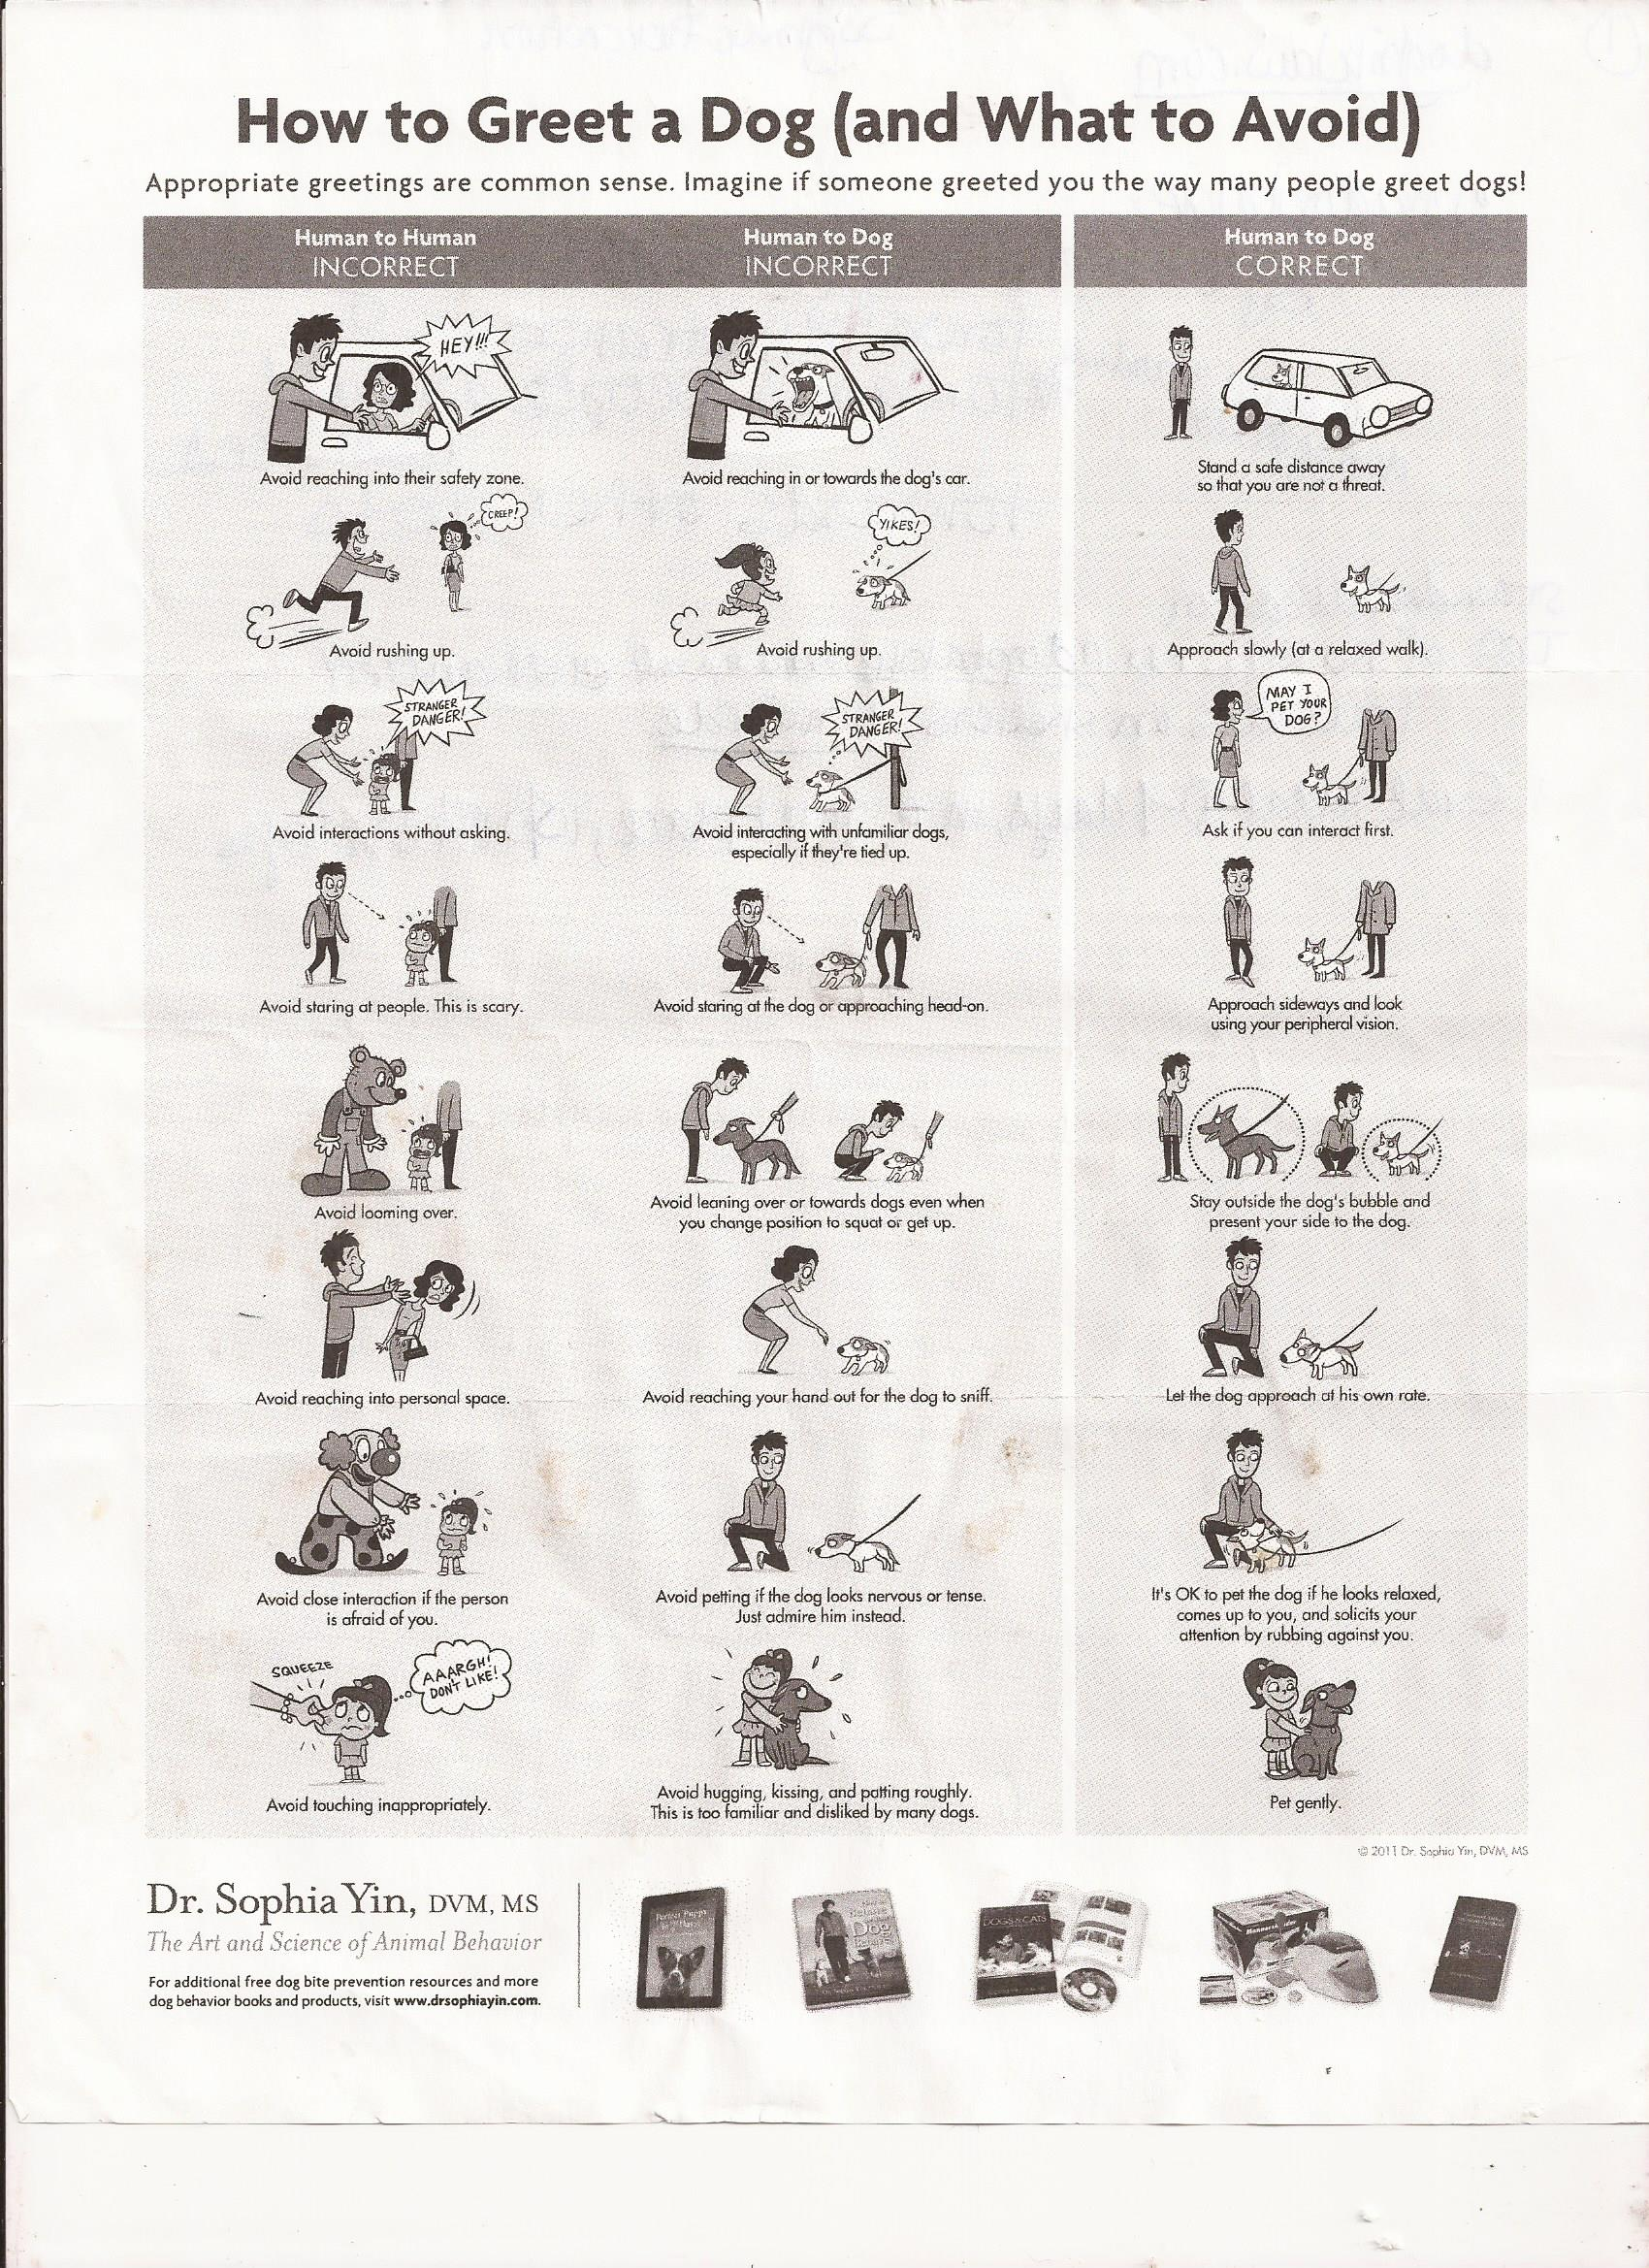Board of Directors

Nicole Roberts, President

As a 16+ year resident of Templeton, Nicole's community connections have been a great benefit to the shelter. She's been an employee of Salvadore Chevrolet for several years and is a licensed Real Estate agent. Nicole serves on Ahimsa Haven's Fundraising committee. Nicole serves on the Operations and Fundraising committees.

Contact Nicole: n_roberts@comcast.net

Brenda Bourque, Treasurer

Brenda serves as Ahimsa Haven's Treasurer. Her career in banking makes her a great candidate to oversee our finances. She is the Assistant Vice President at Federal Family Savings and works closely with that institution's Board of Directors. She is a devoted cat parent.

Contact Brenda: burkie50@hotmail.com

Ed Poulin, Secretary

Ed started volunteering for Ahimsa in 2013 in order to help his daughter gain volunteer hours for high school. Quickly, working at Ahimsa Haven became a family affair with his wife and son joining in to help. Ed spent much of the last decade caring for his children while his wife kept the family afloat. Prior to that he was a Thermodynamics Engineer for Lockheed Martin where he analyzed ground and rocket fluid systems for Atlas III and
Atlas V. Currently, he is working part-time at PetSmart in Leominster, Massachusetts to fund his growing comic book collection and his family's ever increasing menagerie. Ed serves on the Operations and Fundraising committees.

Contact Ed: ednmich@aol.com

Erin Lovett
Erin serves as Animal Care Coordinator for Ahimsa Haven. A graduate of Massachusetts College of Art, she has several years’ experience in animal health and handling in the veterinary practice setting, where she also designed and implemented fundraising initiatives and collaborative efforts with local shelters and rescues. She has also worked as feline care manager at Baypath Humane Society. Erin serves on the Operations committee.

Contact Erin: kittymepink@yahoo.com

Hope Finch
Hope was an instrumental board member at C.A.R.E. For Your Pet, Inc.

Contact Hope: mygilly@verizon.net

