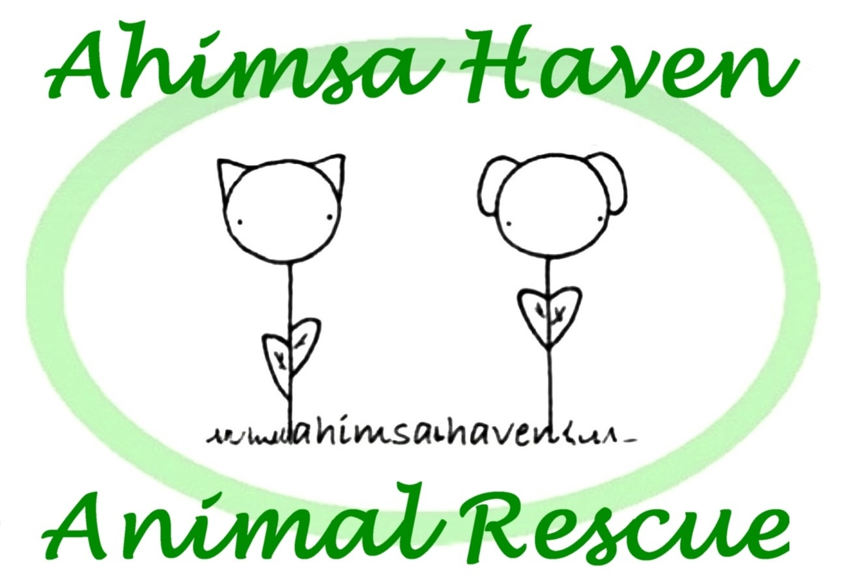

Ahimsa Haven Animal Rescue

Volunteer Handbook - PetSmart Supplement
(revised 3/12/2018)

Index
________________________________________________________________________________________________________________________

Page
Cover

Index

PetSmart

Cat Care
Cat Care - Adoption Room
Cat Care - Quarantine Room

Miscellaneous Care (including type of food for the cats)

Cage Cleaning & Disinfecting

Emergencies

Commandments (aka Ahimsa Rules & Regulations)

Intake

Adoptions

Vaccines, Tests, Treatments
1.

2.

3-5.

6.
7-8.
9-10.

11-12.

13.

14.

15-17.

18.

19.

20-21.

PetSmart
________________________________________________________________________________________________________________________
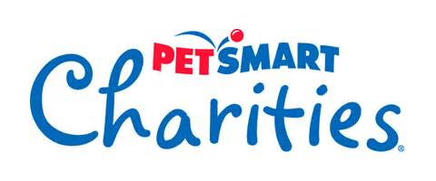

Ahimsa Haven Animal Rescue has partnered with PetSmart Charities (an arm of PetSmart) since 2010. PetSmart adoptions account for 40% of our cat adoptions and PetSmart gives Ahimsa a certain amount of money for each adoption. Thus, it is important for us to maintain a good relationship with PetSmart and follow their rules (excerpted on the next page).

You can learn more about PetSmart Charities at petsmartcharities.org

PetSmart operates as a Pet Shop and follows the guidelines set forth by the Massachusetts Department of Agriculture. One of these requirements is for us to keep the Daily Record Sheet on each cat.

Our cats are generally seen once a week on Wednesdays by Dr. Bianco of Mid-State Mobile Veterinary Clinic and she notes the medical condition of each cat on its Medical Record sheet. She will inform us of any changes to the cat's health that she notices but it is a good practice for all volunteers to make note of medical issues on the Daily Record Sheet.

PetSmart supplies the food, litter, and cleaning supplies. If you run out of any of these then you can ask a manager at PetSmart for more. Currently, we are required to use Authority, Simply Nourish, or Great Choice brands, all PetSmart exclusive brands.

Finally, there are quarterly Adoption Event Weekends. These are weekends that PetSmart promotes with their advertising and we must have people to host some Open Hours during these weekends. They are a good way for the public to get to know us as it is not always apparent to visitors to PetSmart that Ahimsa Haven Animal Rescue is doing the rescuing!

Summary of Partnership: Treat customers with respect; promote a positive image of both the Ahimsa Haven and PetSmart; wear badge that identifies you as an adoption volunteer.

PetSmart
________________________________________________________________________________________________________________________

Excerpted from PetSmart Adoption Partner Manual-2014...

Personnel Expectations
Safety for pets and people is our number one priority. For our adoptions program, we also focus on providing safe, rewarding interactions between potential pet parents and pets as they get to know one another.

In order to ensure a comfortable safe experience for pets and pet parents, adoption partner personnel are expected to conform to some basic expectation:
Volunteers must be at least 14 years old; any volunteer under the age of 18 must be accompanied by an adult at all times.

All employees must be 18 years or older.

All adoption partners are required to use a volunteer waiver and ensure it is signed by each volunteer and on file at the organization’s facility or office. The waiver must include language that waives any and all claims against PetSmart and PetSmart Charities and PetSmart Charities of Canada.

The adoption partner must provide a schedule for personnel, which should be agreed upon by PetSmart store management. Personnel are expected to be on time and pets must be ready for adoption on schedule. Should the schedule need modification, the PetSmart store managers should be notified immediately.

PetSmart stores and PetSmart/PetSmart Charities/PetSmart Charities of Canada events are drug and alcohol free. Adoption partner personnel may not work in a PetSmart store or at an event while under the influence of any controlled substances.

For the safety of the pets and pet parents, relatives, friends, or significant others of adoption partner personnel may not visit during a staff member’s shift unless they are also adoption partner personnel.

For the safety of the pets and pet parents, personal pets may not visit during adoption partner shifts.

Harassment and discrimination are not tolerated and are grounds for immediate termination from the adoption program.

Personnel may not eat meals in any public area of the PetSmart store or 7 Day Cat Adoption Center.

PetSmart
________________________________________________________________________________________________________________________

Adoption partner personnel must make personal store purchases before or after an adoption shift. Product may not be set aside during the shift to be purchased at a later time. Any purchases should be removed from the store immediately.

Personal belongings should be left at home. PetSmart and PetSmart Charities are not responsible for lost or stolen personal items.

Adoption partner representatives shall not disparage PetSmart, PetSmart Charities, or any PetSmart products, services, or associates; Banfield the Pet Hospital or its associates; or the activities or reputations of any other organizations participating in the adoption program.

PetSmart Charities Inc. and PetSmart Charities of Canada Confidential
Adoption partner personnel should dress professionally and in accordance with PetSmart’s appearance/dress code:

o Wear modest attire (such as jeans, t-shirts with or without organization logo) and closed-toe shoes.

o Some attire is specifically not allowed. This includes shorts, skorts, sweat pants, sweatshirts (except company-sponsored sweatshirts), jogging suits, jean bib overalls, leggings, lycra, stirrup pants, mini-skirts, spaghetti-strap dresses, tank tops, halter tops, slippers, and flip flops or thong sandals.

o For the safety of pets and personnel, a minimal amount of nonhazardous jewelry may be worn.

o Hair should be clean and conservatively styled in a way that will not cause a hazard. Men with shoulder length or longer hair must secure hair in a ponytail. Facial hair should be closely trimmed, neat and professional.

o For everyone’s safety, personnel should not chew gum or tobacco while working.

Remember, you are a representative of your organization; your appearance will shape the expectations of potential adopters.

Cat Care
________________________________________________________________________________________________________________________

#1 Rule: Do Adoption Room before Quarantine Room!

The animals in the Adoption Room are cared for before those in the Quarantine Room because it is assumed that those animals are free of communicable diseases but the same cannot be said of those cats in the Quarantine Room. You would not want to transmit something from a potentially unhealthy cat to a healthy one. Please do not go back and forth between the two rooms as that risks spreading disease to the Adoption Room - at the very least, keep your hands off all kitties in the Quarantine Room until you are done with those in the Adoption Room.

Even though the assumption is that all of the Adoption Room cats are healthy we still disinfect our hands in between cleaning of cages because we can't be 100% sure that all of them aren't carrying some bacteria or virus. This is also why you want to wash your hands before leaving PetSmart. You don't want to bring anything home to your kitties!

For disease and injury prevention, do not allow cats to interact with other cats unless housed in the same enclosure. Also, use a separate litter scoop for each enclosure.
________________________________________________________________________________________________________________________

The key to both rooms is typically located at register #1 at the front of the store.
________________________________________________________________________________________________________________________

Cat Care
________________________________________________________________________________________________________________________

Adoption Room

Before you start your shift, please sign your name and time of entry on the Sign-in Sheet in the Adoption Room. Also, be sure that the main door (especially) and secondary door are closed when cleaning the cages. If you leave the Adoption Room make sure both doors are closed to keep curious customers from entering and interacting with the kitties when you are not there.

For each Enclosure:

- Remove litter box; scoop and replace litter if necessary. If visibly soiled, litter box must be cleaned in the utility sink located in the back stockroom.

- Remove blankets & shake out. Replace if wet or soiled. Blankets are below the cages.

- Remove food and water dishes. Empty dirty water in bucket. Clean and refill water dish using the water jugs. Refill food dish from food located under the cages. Discard food and wash dish in the employee break room if visibly soiled before refilling.

- Sweep enclosure, spot clean with clear “Virex II” solution where necessary.

- Wash windows with “PERdiem” if visibly soiled.

- Replace cleaned/replenished items to the cage. Try to keep the water and food bowls separate.

- Clean litter scoop. Remove any visible soil or debris and then spray and clean with Virex II before re-hanging on the enclosure door.

- Write animal info on Daily Record Sheet, noting any issues or even good things about the cat!

- Disinfect hands with disinfectant (on the wall) before proceeding to the next cage.

Cat Care
________________________________________________________________________________________________________________________

When all enclosures are done:

- Sweep the floor.

- Remove trash bag and replace with a new one. Bring full bag and water bucket to the back stockroom. Place the trash in a trash container (or near it) and dump the water in the utility sink. Sometimes too much stock is in the way and you may have to put the bucket away unemptied.

- Wash the floor using the wash bucket and mop, generally found in the back stockroom.

- Review what items might need replacing:

- Fill the water jugs in the employee break room (next to the men's room).
- Get more paper towels from the training room (across from the break room) or ask a manager if it is locked.
- Get more trash bags from the training room (across from the break room) or ask a manager if it is locked.
- Do Virex II or PERdiem bottles need refilling (back stock room above utility sink)?
- Do we need more food? Ask a manager.
- Do we need more litter? Ask a manager.

Do not remove any merchandise from the store shelves without approval. All merchandise, even if donated by a customer, MUST be marked with a yellow inventory control sticker.
________________________________________________________________________________________________________________________

Before you move on to the Quarantine Room, please write down your time of departure on the Sign-in Sheet. Please leave the Adoption Room as you found it.
________________________________________________________________________________________________________________________
Cat Care
________________________________________________________________________________________________________________________

Quarantine Room

Before entering the Quarantine Room try to peek in to see if a cat might be roaming out of its cage. If you cannot see through the window then open the door just a crack to check. Be sure that the door is closed when cleaning the cages. If you leave the Quarantine Room make sure the door is closed to keep curious customers from entering and interacting with the kitties when you are not there.

For each Enclosure:

- Remove litter box; scoop and replace litter if necessary. If visibly soiled, litter box must be cleaned in sink.

- Remove blankets & shake out. Replace if wet or soiled. Blankets are above the cages.

- Remove food and water dishes. Empty dirty water in sink. Clean and refill water dish from the faucet. Refill food dish. Discard food and wash dish if visibly soiled before refilling.

- Sweep enclosure, spot clean with clear “Virex II” solution where necessary.

- Replace cleaned/replenished items to the cage as in the picture. It would be nice to keep the water and food bowls separate like in the Adoption Room but space doesn't allow this except in the bottom cage if the cage divider is removed. If you put the food/water in front of the litter box rather than in front of the bedding area, litter tends to get kicked into the bowls.

- Clean litter scoop. Remove any visible soil or debris and then rinse under the faucet before re-hanging on the enclosure door.

- Write animal info on Daily Record Sheet, noting any issues or even good things about the cat!

- Wash hands with soap and water at the sink before proceeding to the next cage.

Cat Care
________________________________________________________________________________________________________________________

When all enclosures are done:

- Sweep the floor.

- Remove trash bag and replace with a new one. Bring full bag to the back stockroom. Place the trash in a trash container or near it.

- Wash the floor using the wash bucket and mop, generally found in the back stockroom.

- Review what items might need replacing:

- Get more paper towels from the training room (across from the break room) or ask a manager if locked.
- Get more trash bags from the training room (across from the break room) or ask a manager if locked.
- Do Virex II or PERdiem bottles need refilling (back stock room above utility sink)?
- Do we need more food? Ask a manager.
- Do we need more litter? Ask a manager.
________________________________________________________________________________________________________________________

Before leaving the Quarantine Room, be sure to wash your hands so as not to bring any harmful viruses/bacteria back to your own kitties. Please leave the Quarantine Room as you found it.
________________________________________________________________________________________________________________________

Miscellaneous Care
________________________________________________________________________________________________________________________

Disinfecting of a cage is done after the cage has been emptied through adoption or for some other reason. This is handled by volunteers who have been trained per the disinfecting instructions in the next section. No cat is to be placed in a cage that has not been disinfected no matter how free of disease we may think the prior occupant was!

Dirty dishes/scoops/litter boxes go in Quarantine Room sink for washing. Dirty blankets and towels, after removing as much debris as possible, go in the clothing basket. If you need to transport something from Adoption to Quarantine that is particularly yucky then put it in a trash bag first and discreetly bring it to Quarantine. Customers do not need to see grotesque stuff! Things can quickly pile up in the Quarantine Room sink if volunteers are leaving the task for the next person. We tend to have a lot after a good weekend of adoptions. So, please take the time to clean the dishes with warm water and dish soap and place them on a towel or blanket on the table in the Quarantine Room. Someone trained in the disinfecting protocol will take it from there. If you need a clean dish/scoop/litter box then take them from the shelving in the Quarantine Room or from the shelves above the cages in the Adoption Room. These have been disinfected.

The food supply will run out from time to time and needs to be replenished. Please see a PetSmart manager for more. It is a good idea to use up what is available before dumping a new bag of food in the food bins. This way, old food isn't at the bottom. Also, don't dump a new bag of food with the scoops still in the container or we may not find those scoops for weeks! Oftentimes, the managers don't even know what we use so here is a guide:

Current Dry Food: Authority - Indoor Salmon.
Current Wet Food: Authority - Any flavor but pate seems best.
Current Litter: Varies at the PetSmart manager's discretion but a store brand is preferred.

Virex II for is for general cleaning and disinfecting. When you run out you can refill the bottle from the dispenser in the back stockroom.

PERdiem is used for cleaning the windows. When you run out you can refill the bottle from the dispenser in the back stockroom.

The current managers are Karl (Head Manager), Bruce, Joshua, Sam, and Sue.

Customers: As an Ahimsa representative, you may find that PetSmart customers are interested in the cats that you are caring for. If you are comfortable you may allow them into the Adoption Room to interact with the kitties. You must follow the COMMANDMENTS outlined elsewhere in this manual. It is important to make sure that both doors are closed before opening a cat's cage. We do not let customers into the Isolation Room unless ALL of the kitties have been seen and approved by the veterinarian.
Miscellaneous Care
________________________________________________________________________________________________________________________

Forms: If you need a new form like the Daily Record Sheet there are generally more in the filing cabinet in the Adoption Room files. If not, you can take the pink USB in the filing cabinet and insert it into the printer in the clock room at the front of the store to make some copies. Remember to return the USB to the cabinet. Alternatively, you can take the master copy from the Master Copies Binder in the cabinet and make copies on the copier in the clock room. At this time, the printer is the better option as it makes cleaner prints.

The whiteboards are used for volunteers to communicate useful information like "Fluffy swiped at me today" or "Blackie hasn't pooped in 3 days" and each note should be accompanied by your name and a date. They are NOT for complaining about your fellow volunteer. If there are complaints to be made then please contact the Ahimsa Manager in charge of PetSmart operations.

Be considerate of the volunteer who comes after you and try to remember to resupply the food, paper towels, water, etc...

Cage Cleaning & Disinfecting
________________________________________________________________________________________________________________________

A cage must be cleaned of debris and items used for the previous cat such as blankets, litter box, and toys, etc. must be removed. Typically, items used by a cat will travel over to the Adoption Room with them but sometimes they don't make it over there. For example, the cat may have been adopted straight from Isolation.

  - Dirty blankets: Shake out in the trash basket and then put into the laundry basket.
  - Toys:
    - Plastic:These can be washed and reused. Put dirty toys in the sink.
    - Soft: If you think they can be washed then put them into the laundry basket. Otherwise, throw them away.
    - Other: Toys with feathers are a good example. We really cannot wash these so these should be thrown away.
  - Litter boxes: Empty used litter into the trash basket and put litter box into the sink. Make sure that any litter that may be sticking to the box is scraped off before putting in the sink as the litter could clog the drain. If the litter box is a disposable one then throw it away.
  - Litter scoop: Take off as much of the litter debris as possible and then put the scoop into the sink.
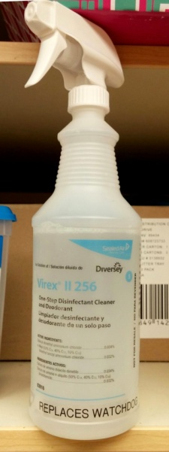
  - Clipboard: Put into the sink. If the clipboard is not plastic, say fiberboard, then throw it away.

Sweep out the cage of debris, such as cat litter. The disinfectant used in the next step cannot work properly
if there is still litter in the cage.

Virex II 256: This generally clear liquid is in a clearly marked spray bottle. If you need more then you can
ask a PetSmart manager to get you more or get it yourself from the warehouse if you know how to.

Spray all surfaces of the cage, including the cage door and the plastic sitting box used by the cats for resting
(if there is one). Be careful not to spray any animals or their food/water dishes. Leave the disinfectant on for
15 minutes. At the end of the 15 minutes wipe away any excess with a towel (you can use paper towels but you
end up using a lot of them). Wipe down the surfaces with a wet paper towel to remove remaining disinfectant.

Emergencies
________________________________________________________________________________________________________________________

Call or text Laura, Ed, Nicole, or Erin immediately if you observe:

- Profuse vomiting/diarrhea.
- Discharge from nose or eyes that is a color other than clear or brownish/reddish.
- Animal has not eaten in over 24 hrs.
- Animal is drinking excessively.
- No urine in 24 hrs/no bowel movement in 3 days.
- Lethargic/unresponsive.
- Signs of obvious injury.
- Heavy sneezing/coughing.
- Excessive lashing out.

All other observations may be noted on each animal’s chart.

Laura: 978-895-0199
Ed: 774-254-2517 (text is best)
Nicole: 508-654-8977 (text is best)
Erin: 978-273-5821 (text is best)

Commandments
________________________________________________________________________________________________________________________

Open Hours Policies & Procedures

The purpose of open hours at Ahimsa Haven is to showcase our animals in a safe setting, and give access to the public. The most important job of a volunteer working Open Hours is to encourage appropriate interactions between visiting guests and our animals. This is one time where the customer is not always right! We expect or visitors to abide by the same rules outlined for us in the volunteer handbook:

Commandments of PetSmart conduct
(A guide for volunteers and visitors)

- Visitors shalt not pick up the kitties. Not all cats enjoy being held. Attempts at hugging, cuddling, or holding cats (who are not in their home environment and therefore stressed) invites injury.
- Thou shalt not put thy face within close proximity to any animal.
- Thou shalt treat the animals with kindness at all times. Hitting, yelling, and other forms of torment (even in the guise of “training”) will not be tolerated.
- Thou shalt not forcibly pull animals out of enclosures or hiding places. Please respect their personal space.
GOLDEN RULE:
Thou shalt closely supervise children under 18 AT ALL TIMES
to ensure they are adhering to all commandments.

Commandments
________________________________________________________________________________________________________________________

Also equally important, please refer to each animal's cage card for handling restrictions. Handling restrictions will be clearly marked on each animal's cage card. Volunteers who disregard handling restrictions will be subject to disciplinary action up to and including termination.

- Animals who have a bite history must have no contact with minors and are not to be handled by visitors during Open Hours.
- No pets may visit our animals without a completed application and an appointment.
- Volunteers must be screened and trained. Please refer anyone wishing to volunteer to the Volunteer Application online or give them a paper application.

Our Application Process:

We hope you often encounter a visitor who falls in love with one of our animals! The most efficient way to start the process is to complete an application online. An application completed at PetSmart may not be collected and processed by an adoption coordinator for several days but, of course, not everyone has internet access and must use the paper form. In the meantime, several applications may have been submitted online and processed, while that one sits waiting to be picked up.

- We do not take deposits. A deposit implies a promise of purchase, and all adoptions are subject to review of an application.
- We do not “hold” animals. There is often a list of animals waiting for space to open up at our shelter, some of whom run the risk of being euthanized. Our goal is to make space for the next animal as quickly as possible.

“Foster to adopt”: In cases where an animal has special behavioral or medical needs, the shelter manager may choose to allow an applicant to “foster to adopt” under our TAKE A CHANCE ON ME program. This is offered as an exception to the norm, and should not be offered to potential adopters as an option.

Our goal is to make a good match between an animal and an adoptive person/family. We do not base our decisions on “first come first serve” but take many factors into consideration such as: previous pet experience, lifestyle, etc. An adoption associate will discuss with you our adoption policies soon. Eliciting truthful answers on the application is key to our efforts to make a good match - please resist the temptation to coach a potential applicant on how to “get around” our adoption policies.

Commandments
________________________________________________________________________________________________________________________

Relinquish Requests:

Our shelter space is limited, and intake is done by appointment only. Under no circumstances do we accept walk-in surrenders. Guests looking to surrender an animal should be provided with our business card and referred to our online surrender form (preferred) or voicemail line, to their local animal control agency, or to the MSPCA in Methuen.
________________________________________________________________________________________________________________________

Intake
________________________________________________________________________________________________________________________

Intake of animals is done only into the Quarantine Room and only by qualified volunteers. You can check out our intake process by referring to the PetSmart Intake Procedure located in the Quarantine Room.
________________________________________________________________________________________________________________________

General Intake Policy:

Ahimsa Haven’s two shelters have space to humanely house five dogs and fifteen cats (Templeton), twenty cats (Winchendon), and PetSmart can house approximately ten cats.

Intake priority is as follows:

Abandoned and not being cared for
Animal control
Owner/stray surrender

Feral TNR programs aside, volunteers of Ahimsa Haven do not work in the field to capture stray animals. (Cats trapped in a TNR program who are obviously friendly, or young enough to be successfully socialized, may be accepted into our foster or adoption program.)

Citizens requesting to relinquish stray cats should be advised on steps to ensure the cat is not owned. Cats may be accepted as space allows, and if they are easily able to be placed in a carrier. We are not able to accept cats that arrive in traps, and may choose to limit the number of senior or shy cats that are in the adoption program at any one time.

We are able to accept dogs who do not pose a significant threat to the public, our volunteers, or other animals. Citizens requesting to relinquish stray dogs should be referred to Animal Control.

Owners requesting to surrender their owned animals (or the strays they are feeding) should be urged to have vaccines and testing done prior to surrender (cats: rabies, fvrcp, and fiv/felv test; dogs: rabies, dhpp, bordatella and 4dx test), or a donation to cover the costs of those services at the time of surrender.

Stray, wounded animals should be referred to animal control.

Adoptions
________________________________________________________________________________________________________________________

Adoptions are done from the Adoption Room by qualified volunteers. You can review the process by checking out the PetSmart Adoption Procedure located in the filing cabinet in the Adoption Room.
________________________________________________________________________________________________________________________
Info for Potential Customers:
For more details on the animals up for adoption check out our website at: ahimsahaven.org

Steps To Adopt:

- Fill out the online Adoption Application*
- Wait for approval of the application
- Pick up your new companion

* A paper version can be submitted if you do not have internet access. The process is slower since a volunteer has to pick it up and deliver it whereas the online version gets emailed straight to the appropriate Adoption Coordinator.

Vaccines, Tests, Treatments
________________________________________________________________________________________________________________________

There are a number of PetSmart requirements for any cat at PetSmart. Specifics can be found in their Adoption Partner Manual.

- The cat must be spayed or neutered prior to coming to PetSmart.

- The cat must be up to date with their rabies and distemper vaccines prior to coming to PetSmart and the appropriate paperwork/certificate must accompany them.

  - Rabies: Typically good for one year. Tags may be supplied but are not necessary.
  - FPV: Feline panleukopenia virus. Highly contagious and can be fatal.
(aka Distemper)

- No cat can arrive at PetSmart until at least 48 hours after receiving the rabies or FCVRP vaccines.

  - FCVRP: Short for vaccinations covering FVR, FCV, & FPV. Kittens get 4 shots starting at 6-8 weeks and adults get a yearly booster.
  - FVR: Feline viral rhinotracheitis
  - FCV: Feline calicivirus
  - FPV: Feline panleukopenia virus.

- No cat can have FIV or FeLV. If we find that we have brought one erroneously to PetSmart a sign should be clearly placed on the cage and the cat must be removed as early as possible. Once removed the cage must then be thoroughly cleaned and disinfected.

  - FIV: Feline immunodeficiency virus. Cats can live a long time with this virus but their immune system is somewhat compromised.
The virus is not easily transmitted and cats who are FIV+ are still allowed to free roam at our shelter as long as they are well
behaved.
  - FeLV: Feline leukemia virus. Transmitted fairly easily among close quartered cats and very often fatal.

- All cats must be onsite at PetSmart at least 48 hours prior to being seen by the vet.

Vaccines, Tests, Treatments
________________________________________________________________________________________________________________________

Schedule of Vaccines, Tests & Treatments:

FVRCP: At age 6 weeks, series of three 3-4 weeks apart if under 1 year old
Worm/flea treatment: At 8 weeks & over
Spay/neuter: At 8 weeks & over
Microchip: At spay/neuter or at 8 weeks
Rabies: At 16 weeks
Snap test*: At 8 weeks
________________________________________________________________________________________________________________________

* FeLV/FIV combo test: This is a test used to determine if the cat has FeLV and FIV. Being negative on this test is one of the requirements of PetSmart. Often you will hear us speak of the "Snap Test". That is a name brand designation and that kit also checks for heartworm infection.

________________________________________________________________________________________________________________________

Currently, Dr. Bianco of the Mid-State Mobile Veterinary Clinic usually sees the cats on Wednesdays so if we want her to check out the cat then we want to get it into the Quarantine Room by Monday morning.

